Customer Discovery Findings

# Table of Contents

**Table of Contents 2**

Farmer 1 3

Farmer 2 4

Notes on the Spreadsheet 5

# 

## Farmer 1

Name: Wayne George

Occupation: Farmer, Bar Owner, Restaurant Owner

Phone Number: (585) 535-7410

Date & Time: 7/25/23 at 4pm

Time Duration: Around 10 min

Farmer’s Observations:

* Thinks that manure additives are not worth the price
* Prefers traditional methods of distributing manure (spreading over field)
* Is aware of solutions to combat the smell of manure
  + Molasses mixed within the manure
* Is not interested in corporate solutions and additives
* Has 30 cows and 100 heifers
* Chooses to just ignore/get used to the smell of the manure
  + Offers gas cards and a free steak
* Hears about products through farmer friends/association

Key Takeaways:

* Is a small farm owner who believes in more traditional methods of farming
* He is skeptical of commercial products mainly due to cost
* Main method of hearing about news is through his farmer friends and his community/association

## 

## 

## Farmer 2

Name: Bill Donahue

Occupation: Farmer from Wisconsin

Phone Number: (715) 688-9054

Date & Time: 7/31/23 at 8pm

Time Duration: Around 10 min

Farmer’s Observations:

* 300-1500 cows
* 2500 cattle and 2,000 acres of land
* Wife’s family owns it
* The farm has 150 years of history
* Born into farming and did it for 60 years
* He manages a different family farm and has 60 employees (harvest milk from cows and care for cows)
* His job used to be caring for animals
* Now handles day to day operations on the farm
* He only spent one day of life in industry in Cool Whip Factory not his cup of tea
* Loves being outdoor with animals and loves creating the products for customers
* Every day is different with unique challenges
* For livestock the general challenge is **keeping the animals healthy** as well as treating any illnesses they may have
* Input and output cost is not controlled by farm as it depends on the market
* Climate friendly or not friendly with constantly moving target
* Numerous **consultants** such as **veterinarian** or **nutritionist** to determine the products they use and the amount of feed to give animals
* Several agricultural periodicals with an online presence
* Doesn’t classify odor as a problem but tries to mitigate it
* Uses manure to fertilize crops even though it has increase odor
* Humidity or rain can affect odor
* Numerous tutor groups bring kids to farm with smell as a nuisance
* Several products in industry to help by cost-benefit ratio prevents them from taking off
* No product adopted to mitigate odor
* Hasn’t been anything he's aware of that is highly effective not to mention cost

Key Takeaways:

* Doesn’t want to adopt manure products because their cost outweighs the benefits
* Would rather just put up with the odor and use traditional methods to mitigate the odor
* Has a genuine passion for farming and wants what’s best for his livestock
* Uses the internet to find and research new products for the farm
  + However he mainly gets advice from his veterinarians and nutritionists

## Notes on the Spreadsheet

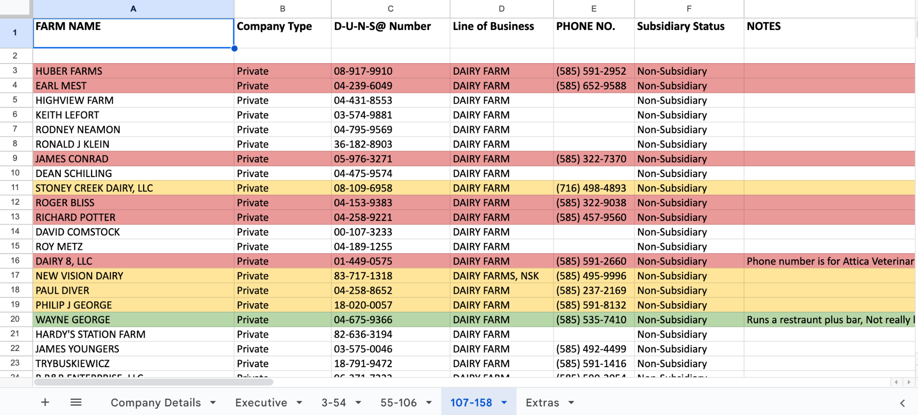

Red - Phone number is not in use or they said no.

Yellow - No one answered the call, so we left a voice message. But we didn’t hear back from them.

Green - We successfully connect with them.

Something to note is that most of the contacts were outdated in the sense that some of the farms have already been sold or they have pivoted from being a dairy farm.